Radiocarbon sampling, plots 1-4 A and B, once during the last week of August

1. Place the chamber on the base, being careful not to breathe in the chamber. If you use a chamber marked “B,” use gloves when handling the chamber to avoid contaminating the canister and connector with residual enriched glucose on the chamber.
2. Attach tubes from soda lime system (Darryl or Darlene) to the ports of the chamber using Swagelok compression fittings. Finger-tight is good enough.
3. Scrub for 20 minutes: turn on soda lime system and run it for 20 minutes. (Make sure the pump turns on (and stays on). If you don’t hear the pump turn on when you flip the switch, jiggle the power switch. – Darlene can be a little testy this way.) Record the time you start scrubbing.
4. After 20 minutes of scrubbing, turn off the soda lime system and record the time you stop scrubbing. Quickly remove the tubes from the chamber’s sampling ports, replacing them with the septa and Swagelok fittings you removed in step 2. Do this carefully to minimize airflow through the ports. Again, careful not to breathe in the chamber.
5. Leave the chamber in place for 5 hours.[1]*
6. After 5* hours, test the CO2 concentration in the chamber.
   * Using a 60 mL syringe, mix the gas in the chamber with 3 syringe plunges through the chamber’s septum.
   * Collect 35 mL into the syringe (with stopcock).
   * Inject the sample slowly and steadily through the LI-COR inlet to test the CO2 concentration in the chamber.[2]**
   * Record the chamber name, time, and CO2 concentration.
7. Determine the sample size necessary, based on the CO2 concentration.
   * If above 10,000 ppm, use a 160 mL vial.
   * If 2,000 – 10,000 ppm, use a 500 mL canister.
   * If 1,000 – 2,000 ppm, use a 1,000 mL canister or 2 500 mL canisters.
   * If below 1,000 ppm, leave the chamber on longer.
8. Collect the sample.
   * Procedure if you’re sampling with a canister:
     1. Assemble the connector (see figure).
        1. Remove septa from both ends of the water trap, being careful not to lose the o-rings.
        2. Attach one end of the water trap to the connector’s capillary tubing using the water trap’s ultra-torr fitting. Make sure the o-ring goes around the tube. Tighten the ultra-torr fitting as much as possible with your fingers.
        3. Attach the other end of the water trap to a ¼” stainless steel tube. Again, make sure the o-ring goes around the tube and make it good and finger-tight.
        4. Check condition of the septum in the connector’s 1/8” T fitting.
     2. Attach the connector to the canister. To do this, attach the tube coming from the connector’s water trap to the canister using the stainless steel compression fitting. Be careful not to cross-thread it, since the canister’s valve is expensive to replace. Use wrenches to tighten it but don’t crank too hard.
     3. *Carefully* attach the flow restrictor end of the connector to one of the chamber’s ports. Use nylon ferrules and a nut made from the same material as the chamber port, swapping the connector’s nut for the chamber port as quickly as possible to minimize airflow through the port. As usual, don’t breathe into the chamber port while you’re doing this. Use wrenches to tighten it but don’t crank too hard. Make sure the canister is seated well on the ground with the capillary tube bent so that the setup doesn’t pull the chamber off its base.
     4. Using a syringe and needle, draw 30 mL of gas through the septum in the 1/8” T fitting. This is to flush the dead space in the connector before sampling.
     5. Open the green valve on the canister. 1 turn is enough. Record the time you open the valve.
     6. Wait 1 hour, then close the canister. Record the time you close the canister.
     7. Test the pressure in the canister to make sure you got a sample:
        1. Before removing the canister from the chamber, collect 20 mL of chamber gas with a syringe through the other septa port. Close the syringe stopcock.
        2. Double-check to make sure you closed the canister.
        3. Remove the connector from the chamber, quickly replacing the chamber’s nut and septum.
        4. Remove the connector from the canister, replacing it with a ¼” nut and septum.
        5. Insert the needle from your 60 mL syringe into the canister’s septum. Open the syringe stopcock and the canister’s valve. After a few seconds, close the canister’s valve and remove the syringe.
        6. If the syringe plunger didn’t move, great. Everything worked as planned. Exchange the nut and septum for the brass cap the canister started with, and tighten the cap just barely beyond finger-tight.
        7. If, on the other hand, the gas in the syringe gets sucked into the canister, your canister isn’t full. (This might happen if something has clogged the flow restrictor.) In this case, redo the sample collection procedure (step 8), using a different connector.
   * Procedure if you’re sampling with a vial:
     1. You know how to do this. All I’ll add is that you should put 200 mL of gas into the 160 mL vial and record the time you take the sample.
9. You’re done!

Disassembled connector. Top to bottom: connector (flow restrictor on left and capillary on right), water trap, ¼” tube. (You’ll find compression fittings swaged to the ¼” tube.)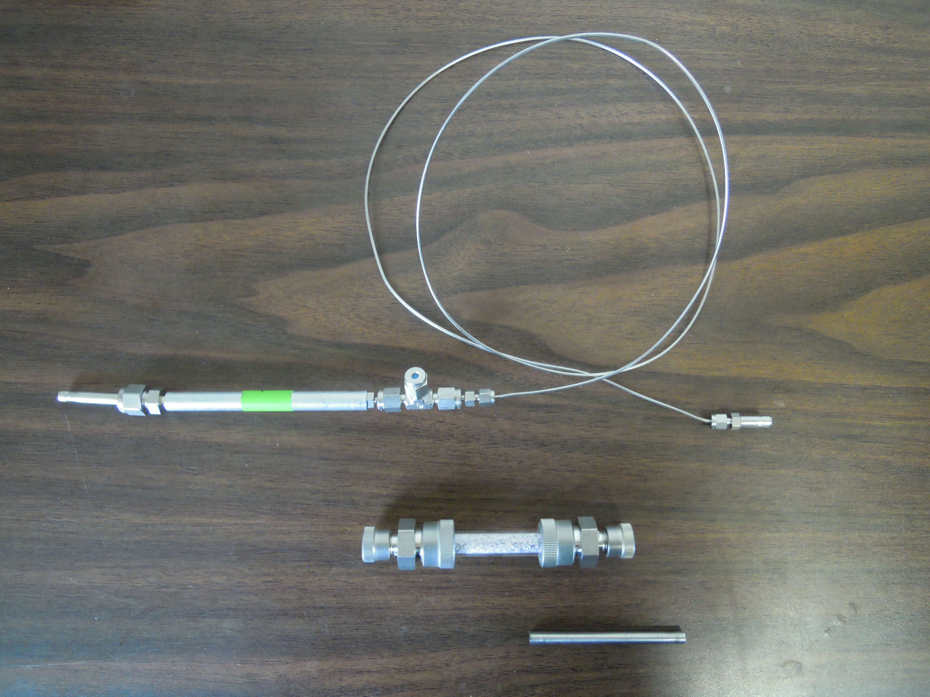

Assembled connector

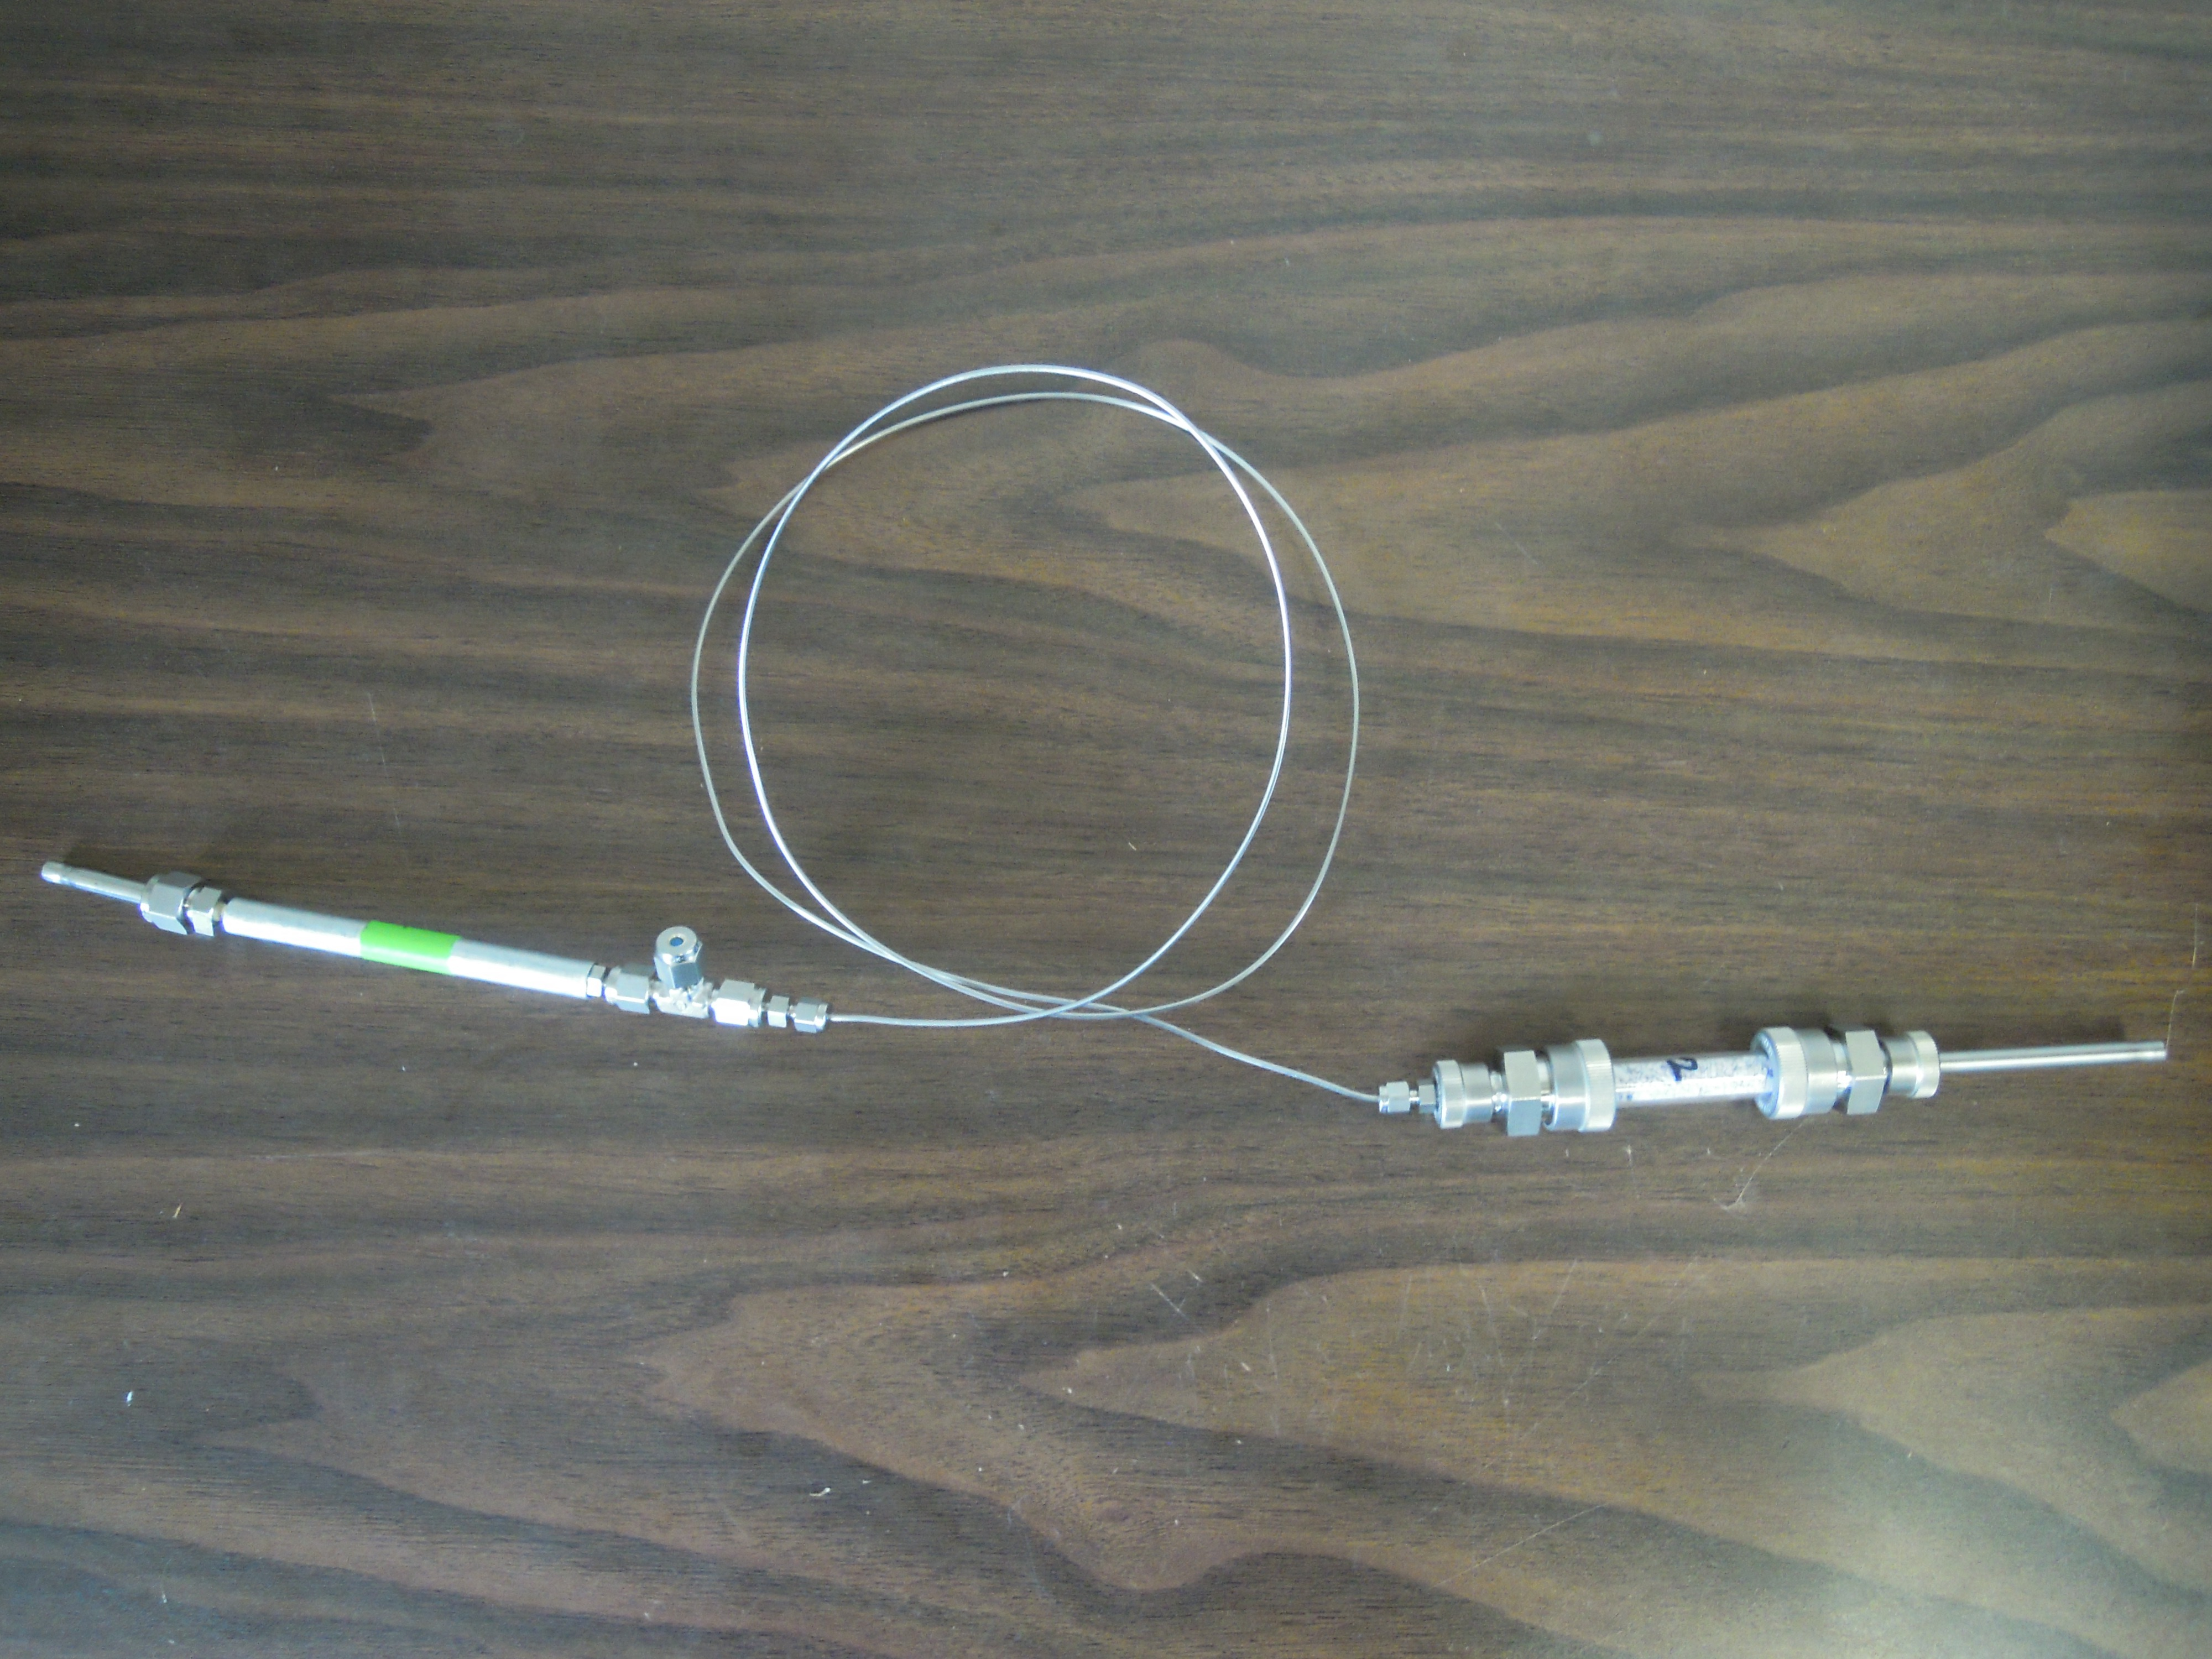

1. * Time will depend on CO2 flux rate. The ideal CO2 concentration in the chamber is 2500 ppm at the time of sampling.
2. ** LI-COR tutorial. Remove the fitting and septum from the port marked “out” and connect the computer to the LI-COR using the cable. Turn on the LI-COR and computer. The computer’s password is LICOR-000. Open the program called Li-820. Click File -> Connect and connect to Com Port 5. Once the cell temperature reaches 50 degrees, you’re good to go.